12.Implement Iris Flower Classification using KNN

Aim
To implement Iris Flower Classification using K-Nearest Neighbours (KNN) in Python and classify iris flowers into their respective species.

Algorithm
- Import the required libraries.
- Load the Iris dataset.
- Separate the input features and target classes.
- Split the dataset into training and testing data.
- Create a KNN classifier with a suitable value of K.
- Train the model using the training data.
- Predict the species of the test data.
- Calculate the accuracy of the model.
- Display the classification results.
PROGRAM:
from sklearn.datasets import load_iris
from sklearn.model_selection import train_test_split
from sklearn.neighbors import KNeighborsClassifier
from sklearn.metrics import accuracy_score

iris = load_iris()

X = iris.data
y = iris.target

X_train, X_test, y_train, y_test = train_test_split(
X, y, test_size=0.2, random_state=42
)

knn = KNeighborsClassifier(n_neighbors=3)

knn.fit(X_train, y_train)

y_pred = knn.predict(X_test)

accuracy = accuracy_score(y_test, y_pred)

print("Actual Classes:", y_test)
print("Predicted Classes:", y_pred)
print("Accuracy:", accuracy * 100, "%")

new_flower = [[5.1, 3.5, 1.4, 0.2]]

prediction = knn.predict(new_flower)

print("New Flower Features:", new_flower)
print("Predicted Flower:", iris.target_names[prediction[0]])

OUTPUT:
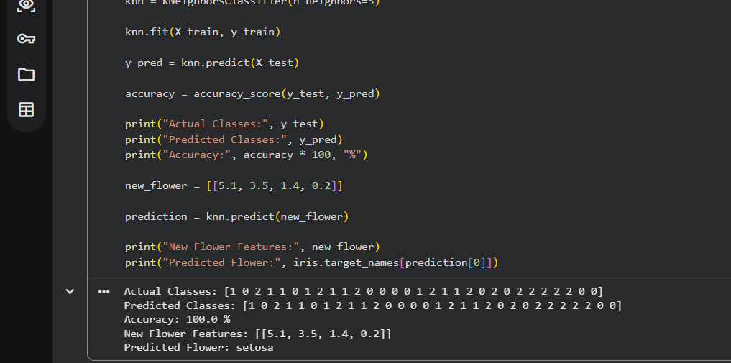

RESULT:
Thus, Iris Flower Classification using KNN was successfully implemented in Python, and the iris flower species was correctly classified.

